מקבץ קודים מסכמים – אנליזה נומרית

תיאור המסמך: מקבץ קודים לשיטות נומריות שנלמדו במהלך קורס אנליזה נומרית.

תנאים מקדימים להרצת הקודים:

- התקנת Python מגרסת 3.6 ומעלה.

- התקנת IDE תומך שפת Python , כדוגמת – PyCharm.

- ייבוא סיפריות Scipy ו- Numpy.

- הבנת השיטות שנלמדו בהרצאות.

מחברים: שלי מירון, אור ממן, איוון רובינסון וסתיו לובל.

___________________________________________________________________

**חלק א':**

שיטות למציאת פתרון של משוואה לא לינארית

1. שיטת החצייה

def findRoots(f, range_start, range_end, acceptable_error = 0):  
 """  
 Finds the root of a polynomial based on range.  
 Input  
 f : polynomial/ function  
 range_start : start range of interval  
 range_end : end range of interval

acceptable_error : the acceptable error to stop the loop  
 Output  
 m : the final root of a polynomial based on bisection algo

"""  
 count = 1  
 m = (range_start + range_end) / 2.0  
 while (range_end - range_start) / 2.0 > acceptable_error:  
 print(**"Iteration num:"**, count, **", result ="**, m)  
 if f(m) == 0:  
 return m  
 elif f(range_start) * f(m) < 0:  
 range_end = m  
 else:  
 range_start = m  
 m = (range_start + range_end) / 2.0  
 count += 1  
 return m

מקור: <http://code.activestate.com/recipes/578417-bisection-method-in-python/>

1. שיטת המיתר

import math  
def findRoots(f, range_start, range_end, iterations=10):  
 """  
 Finds the root of a polynomial based on range.  
 Input  
 f : polynomial/ function  
 range_start : start range of interval  
 range_end : end range of interval

iterations : number of iteration until   
 Output  
 m : the final root of a polynomial based on secant algo

"""  
 for i in range(iterations):  
 print(**"Iteration num:"**, i, **", result = "**, range_end)  
 if f(range_end) - f(range_start) == 0:  
 return range_end  
 x_temp = range_end - (f(range_end) * (range_end –

range_start)* 1.0) / (f(range_end) -

f(range_start))  
 range_start = range_end  
 range_end = x_tem

return range_end

מקור: <http://code.activestate.com/recipes/578420-secant-method-of-solving-equtions-in-python/>

1. שיטת ניוטון-רפסון

from math import *  
  
def findRoots(f, derivative, x0=1):

"""  
 Finds the root of a polynomial based on range.  
 Input  
 f : polynomial/ function  
 derivative : A derivative of a polynomial

x0 : a guess of x   
 output  
 x : the final root of a polynomial based on newton-repson

algo  
 """

acceptable_error = 1e-3  
 x = float(x0)  
 while abs(f(x)) > acceptable_error:  
 x = x - f(x) / derivative(x)  
 return x

**חלק ב':**

פיתרון נומרי של מערכות משוואות לינאריות

1. שיטת גאוס

def gauss(A):  
 """  
 Solves systems of linear equations using Gauss algo

Input  
 A : the matrix with the solutions of it   
 output  
 x : vector that contains the solutions of the equations   
 """

n = len(A)  
  
 for i in range(0, n):  
 # Search for maximum in this column  
 maxEl = abs(A[i][i])  
 maxRow = i  
 for k in range(i+1, n):  
 if abs(A[k][i]) > maxEl:  
 maxEl = abs(A[k][i])  
 maxRow = k  
  
 # Swap maximum row with current row (column by column)  
 for k in range(i, n+1):  
 tmp = A[maxRow][k]  
 A[maxRow][k] = A[i][k]  
 A[i][k] = tmp  
  
 # Make all rows below this one 0 in current column  
 for k in range(i+1, n):  
 c = -A[k][i]/A[i][i]  
 for j in range(i, n+1):  
 if i == j:  
 A[k][j] = 0  
 else:  
 A[k][j] += c * A[i][j]  
  
 # Solve equation Ax=b for an upper triangular matrix A  
 x = [0 for i in range(n)]  
 for i in range(n-1, -1, -1):  
 # Round - approximation  
 x[i] = round(A[i][n]/A[i][i],3)  
 for k in range(i-1, -1, -1):  
 A[k][n] -= A[k][i] * x[i]  
 return x

**חלק ג':**

שיטות איטרטיביות לפתרון של מערכות לינאריות

1. שיטת יעקובי

import scipy  
import numpy as np  
  
  
def Jacobi(A, b, x, n):  
 D = np.diag(A)  
 R = A - np.diagflat(D)  
  
 for i in range(n):  
 x = (b - np.dot(R, x)) / D  
 print(**"Iteration {0}: {1}"**.format(i, x))  
 return x

מקור:

<https://austingwalters.com/jacobi-method/>

1. שיטת גאוס-זיידל

import numpy as np  
from scipy.linalg import solve  
  
def gaussSeidel(A, b, x, n):  
 """  
 Solves systems of linear equations using Gauss-zidel algo

Input  
 A : matrix of linear equations

b : solutions of linear equations

x : vector that contains the solutions of

the equations

n : number of iteration

Output  
 x : vector that contains the solutions of the equations   
 """

L = np.tril(A)  
 U = A - L  
 for i in range(n):  
 x = np.dot(np.linalg.inv(L), b - np.dot(U, x))  
 print (**'**\n**'**,**'Iter '**, i, **':'**)  
 print(x)  
 return x

מקור: [**https://austingwalters.com/gauss-seidel-method/**](https://austingwalters.com/gauss-seidel-method/)

**חלק ד':**

שיטות אינטרפולציה

1. שיטת האינטרפולציה לפי לאגרנז'

import scipy.interpolate as interpol

"""  
 We calculate lagrange interpolation by sending 3 points and

receiving function back  
 Input  
 xp: input x's in a list of size n  
 yp: input y's in a list of size n  
 Output  
 f : the polynomial of degree n-1  
 """  
  
f = interpol.lagrange(xp, yp)  
print(f)  
print(**'f({0}) = {1}'**.format(x , f(x)))

מקור: <https://docs.scipy.org/doc/scipy-0.14.0/reference/generated/scipy.interpolate.lagrange.html>

1. שיטת אינטרפולציה לפי נוויל

def neville(datax, datay, x):  
 """  
 Finds an interpolated value using Neville's algorithm.  
 Input  
 datax: input x's in a list of size n  
 datay: input y's in a list of size n  
 x: the x value used for interpolation  
 Output  
 p[0]: the polynomial of degree n  
 """  
 n = len(datax)  
 p = n*[0]  
 for k in range(n):  
 for i in range(n-k):  
 if k == 0:  
 p[i] = datay[i]  
 else:  
 p[i] = ((x-datax[i+k])*p[i]+ \  
 (datax[i]-x)*p[i+1])/ \  
 (datax[i]-datax[i+k])  
 print(**'P{0}{1} = {2}'**.format(i, k, p[i]))  
 return (**'Result => P{0}{1}({3}) = {2}'**.format(i, k, p[0],x))

מקור:

<https://github.com/gisalgs/geom/blob/master/neville.py#L23>

1. שיטת ספליין-קובי

import GaussAlgo  
import Functions  
  
  
def CubicSplineDerivatives(x_values, y_values, first_derivative, last_derivative):  
 """  
 Solves for the vector of derivatives of the spline function.  
 Parameters:  
 x_values - sorted array of floats  
 y_values - array of floats  
 first_derivative - derivative of spline function at the 1st x_value  
 last_derivative - derivative of spline function at the last x_value  
 Returns:  
 tuple of derivatives for each range  
  
 Please note that it may be broken for non-natural cubic splines  
 """  
 x_values = tuple(x_values)  
 y_values = tuple(y_values)  
 if len(x_values) != len(y_values):  
 raise Exception(**"x_values and y_values length mismatch"**)  
 if x_values != tuple(sorted(x_values)):  
 raise Exception(**"x_values not sorted in ascending order"**)  
  
 intervals = []  
 for i in range(len(x_values) - 1):  
 intervals.append(x_values[i + 1] - x_values[i])  
  
 matrix = ()  
  
 # Presentation slide 7  
 a00 = 1 # intervals[0]/3  
 a01 = 0 # intervals[0]/6  
 ann1 = 0 # intervals[len(intervals)-1]/6  
 ann = 1 # intervals[len(intervals)-1]/3  
 d0 = 0 # (y_values[1] - y_values[0])/intervals[0] - first_derivative  
 dn = 0 # last_derivative - (y_values[len(y_values)-1] - y_values[len(y_values)-2])/intervals[len(intervals) - 1]  
  
 # Presentation slide 8  
 matrix += ((a00, a01) + tuple(0 for _ in range(len(x_values) - 2)) + (d0,),)  
 for i in range(1, len(x_values) - 1):  
 matrix += (tuple(0 for _ in range(i - 1)) + (  
 intervals[i - 1] / 6, (intervals[i - 1] + intervals[i]) / 3, intervals[i] / 6) + tuple(  
 0 for _ in range(len(x_values) - i - 2)) + (  
 (y_values[i + 1] - y_values[i]) / intervals[i] - (y_values[i] - y_values[i - 1]) / intervals[  
 i - 1],),)  
 matrix += (tuple(0 for _ in range(len(x_values) - 2)) + (ann1, ann) + (dn,),)  
  
 return GaussAlgo.gauss(matrix, 7)  
  
  
def CubicSpline(x_values, y_values, derivative_at_x1, derivative_at_xn):  
 """  
 Performs cubic-spline interpolation of unknown function, described by x_values and y_values.  
 Parameters:  
 x_values - sorted array of floats  
 y_values - array of floats   
 derivative_at_x1 - derivative of function at the 1st x_value  
 derivative_at_xn - derivative of function at the last x_value  
 Returns:  
 tuple, where each element is a  
 tuple of coefficients  
 of resulting polynomial  
 for x[i] < x <= x[i+1]  
 in increasing order.  
 coefficients[0] is coefficient of x^0  
 coefficients[1] is coefficient of x^1  
 etc...  
 """  
 x_values = tuple(x_values)  
 y_values = tuple(y_values)  
 if len(x_values) != len(y_values):  
 raise Exception(**"x_values and y_values length mismatch"**)  
 if x_values != tuple(sorted(x_values)):  
 raise Exception(**"x_values not sorted in ascending order"**)  
  
 derivatives = CubicSplineDerivatives(x_values, y_values, derivative_at_x1, derivative_at_xn)  
  
 polynomials = ()  
 for i in range(len(x_values) - 1):  
 interval_size = x_values[i + 1] - x_values[i]  
 if interval_size == 0:  
 raise Exception(**"interval size can not be 0"**)  
  
 coefficients = (  
 # Formula for S_i taken from presentation slide 11, and ran through WolframAlpha  
 (x_values[i] * (x_values[i] ** 2 * derivatives[i + 1] - 6 * y_values[i + 1] - derivatives[  
 i + 1] * interval_size ** 2) + x_values[i + 1] * (  
 derivatives[i] * interval_size ** 2 + 6 * y_values[i] - x_values[i + 1] ** 2 * derivatives[  
 i])) / (6 * interval_size),  
 (derivatives[i] * (3 * x_values[i + 1] ** 2 - interval_size ** 2) + 6 * (y_values[i + 1] - y_values[i]) +  
 derivatives[i + 1] * interval_size ** 2 - 3 * x_values[i] ** 2 * derivatives[i + 1]) / (6 * interval_size),  
 (x_values[i] * derivatives[i + 1] - x_values[i + 1] * derivatives[i]) / (2 * interval_size),  
 (derivatives[i + 1] + derivatives[i]) / (6 * interval_size)  
 )  
 polynomials += (coefficients,)  
  
 return polynomials  
  
  
def NaturalCubicSpline(x_values, y_values):  
 return CubicSpline(x_values, y_values, 0, 0)

def Interpolate(x_values, y_values, derivative_at_x1, derivative_at_xn, desired_x):  
 """  
 Performs cubic-spline interpolation,  
 and returns the value of the function at the desired_x.  
 Does not perform extrapolation - desired_x must be between the 1st x_values and the last.  
 The rest of the parameters are the same as in CubicSpline  
 """  
 funcs = CubicSpline(x_values, y_values, derivative_at_x1, derivative_at_xn)  
 for i in range(len(x_values) - 1):  
 if x_values[i] <= desired_x and desired_x <= x_values[i + 1]:  
 return Functions.evaluateFunction(funcs[i], desired_x)  
 raise Exception(**"desired_x out of range"**)  
  
  
def InterpolateNatural(x_values, y_values, desired_x):  
 return Interpolate(x_values, y_values, 0, 0, desired_x)

**חלק ה':**

שיטות אינטגרציה וגזירה נומריות

1. שיטת הטרפז

import numpy as np  
  
def calculate_area(f, a, b, n):

"""  
 Calculate the integral of a f(x) based on the trappezodial rule.  
 Input  
 f : the polynomial/ function

a : the start range of an integral

b : the end range of an integral  
 n : number of interval  
 Output  
 np.trapz(f(x), x): the integral of f(x)  
 """  
 x = np.linspace(a, b, n + 1)

print(**"number of intervals: "**, n+1)  
 return np.trapz(f(x), x)

מקור: <https://codereview.stackexchange.com/questions/194184/definite-integral-approximation-using-the-trapezoidal-method>

1. שיטת סימפסון

from scipy import integrate  
  
def simpson(y, x):

"""  
 Calculate the integral of a f(x) based on the simpson rule.  
 Input  
 y : y's points – y range of a polynomial

x : x's points – x range of a polynomial

Output

Integral of a polynomial based on particular points

"""

return integrate.simps(y, x)  
  
print(**"Integral:"**, simpson(y, x))

מקור: <https://docs.scipy.org/doc/scipy/reference/generated/scipy.integrate.simps.html>

1. שיטת רומברג

from scipy import integrate  
import numpy as np  
  
def romberg(f, a, b):  
 """  
 Calculate the integral of a f(x) based on the romberg rule.  
 Input  
 f : polynomial/ function

a : x range of integral

b : y range of integral

Output

Integral of a polynomial based on range

"""

return integrate.romberg(f, a, b, show=True)  
print(**"Integral: "**, romberg(f, a, b))

מקור: <https://docs.scipy.org/doc/scipy/reference/generated/scipy.integrate.romberg.html>

1. תרבועי גאוס

from scipy import integrate  
  
"""  
Returns:   
val : float  
Gaussian quadrature approximation (within tolerance) to integral.  
  
err : float  
Difference between last two estimates of the integral.

"""

result = integrate.quadrature(f, a, b)  
print(result)

מקור: <https://docs.scipy.org/doc/scipy-0.14.0/reference/generated/scipy.integrate.quadrature.html>

**נספחי קוד**

1. חישוב מטריצה הופכית

def invert_matrix(A):

return linalg.inv(A)

1. חישוב נורמה של מטריצה

def Norma(A):

sum = 0  
 temp_sum = 0  
 for i in range (len(A)):  
 if temp_sum >= sum:  
 sum = temp_sum  
 temp_sum=0  
 for j in range (len(A)):  
 temp_sum += abs(A[i][j])  
 return sum

1. חישוב Cond

def cond(A):

return Norma(A)* Norma(invert_matrix(A))

1. חישוב LU

import pprint  
import scipy

P, L, U = scipy.linalg.lu(A)

1. חישוב SOR

import numpy as np  
# Define function  
def solveBySOR(A, b, omegaVal, totlVal):  
 # Actual_1 = [1.0,-1.0,3.0]  
 # Actual_2 = [1.0, 2.0, -1.0, 1.0]  
 # Actual_3 = [[3.0,4.0,-5.0]]  
  
 Asize = np.shape(A)  
 rwsize = Asize[0]  
 colsize = Asize[1]  
  
 if rwsize != colsize:  
 print(**"A is not a square matrix"**)  
 exit(1)  
  
 if rwsize != b.size:  
 print(**"Dimensions of A and b do not match"**)  
 exit(1)  
  
 x = np.zeros((rwsize, 1))  
 x0 = np.zeros((rwsize, 1))  
 nk = 0  
 err = totlVal + 1.0  
 maxIter = 200.0  
  
 while err > totlVal and nk < maxIter:  
 nk += 1  
 for i in range(0, rwsize):  
 x0[i] = x[i]  
 mysum = b[i]  
 oldX = x[i][0]  
  
 for j in range(0, rwsize):  
 if i != j:  
 mysum = mysum - A[i][j] * x[j][0]  
  
 x0[i] = x[i]  
 mysum = b[i]  
 oldX = x[i][0]  
  
 for j in range(0, rwsize):  
 if i != j:  
 mysum = mysum - A[i][j] * x[j][0]  
  
 mysum = mysum / A[i][i]  
 x[i][0] = mysum  
 x[i][0] = mysum * omegaVal + (1.0 - omegaVal) * oldX  
  
 diff = np.subtract(x, x0)  
 err = np.linalg.norm(diff) / np.linalg.norm(x)  
 print(np.linalg.norm(err))  
  
 if (nk == maxIter):  
 print(**"Maximum number of Iterations exceeded"**)  
 else:  
 print(**"The solution is:"**)  
 print(x)  
 print(**"The number of iterations used: %d"** % (nk))  
 print(**"Relative error: %.7f"** % (err))

מקור: <https://github.com/lathestudent/Direct-and-Iterative-Solver-of-Linear-Systems/blob/master/Matrix_Solver_Methods.py>

טבלאות נתונים ותרשימים להוכחת נכונות השיטות

שיטות למציאת פתרון של משוואה לא לינארית

בהינתן הקלט הבא:







התוצאות שהתקבלו בכל אחת מן השיטות:

**Bisection algorithm**

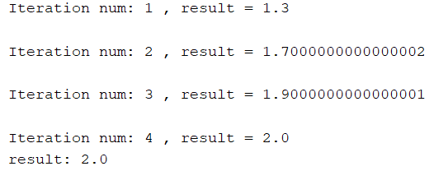

**Secant algorithm**

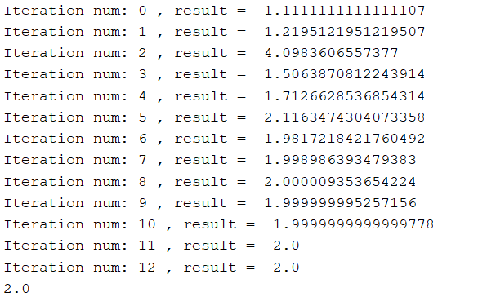

**NewtonRepson algorithm**

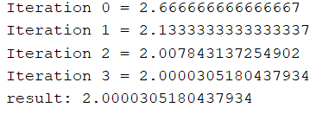

פתרון נומרי של מערכות משוואות לינאריות

**Gauss algorithm**

תרשים המציג את פעולת האלגוריתם לפתרון משוואות לינאריות ע"פ גאוס:

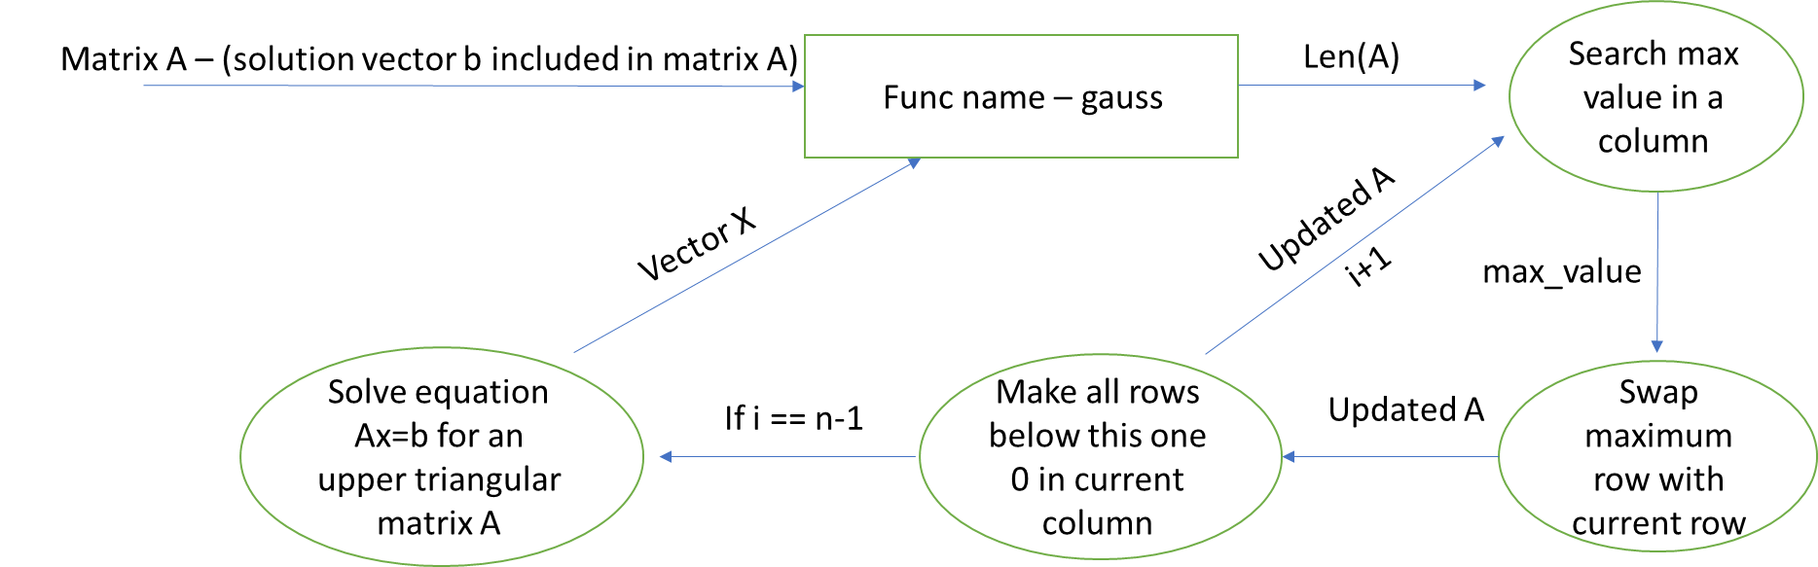

**LU**

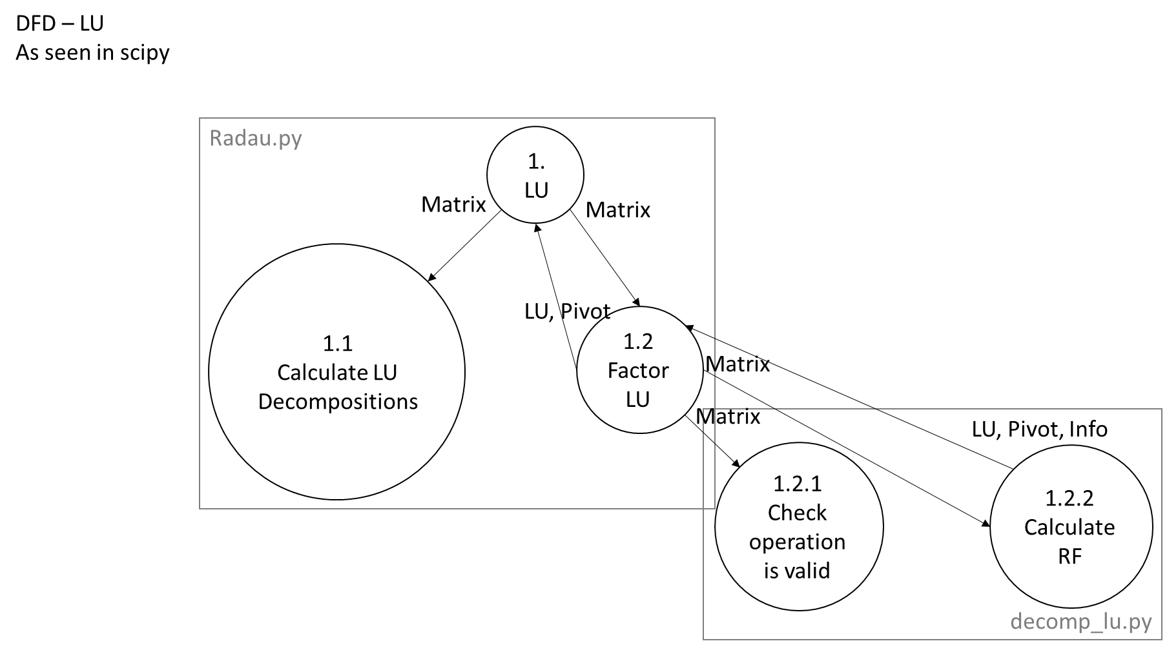תרשים המציג את אופן פעולת הפירוק LU:

שיטות איטרטיביות לפתרון מערכות לינאריות

בהינתן הקלט הבא:

Jacobi(np.array([[5.0, -1.0, 2.0], [3.0, 8.0, -2.0], [1.0, 1.0, 4.0]]), [12, -25, 6.0], np.array([0.0, 0.0, 0.0]), 22)

A = np.array([[5.0, -1.0, 2.0], [3.0, 8.0, -2.0], [1.0, 1.0, 4.0]])  
b = [12, -25, 6.0]  
x = [0, 0, 0]  
  
n = 10  
  
gaussSeidel(A, b, x, n)

**Jacobi algorithm**

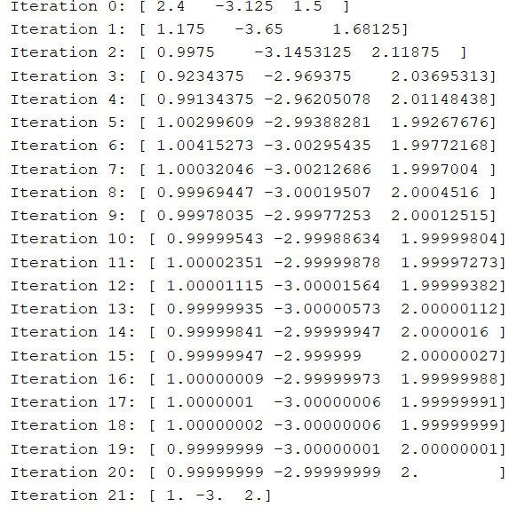

**Gauss-Seidel algorithm**

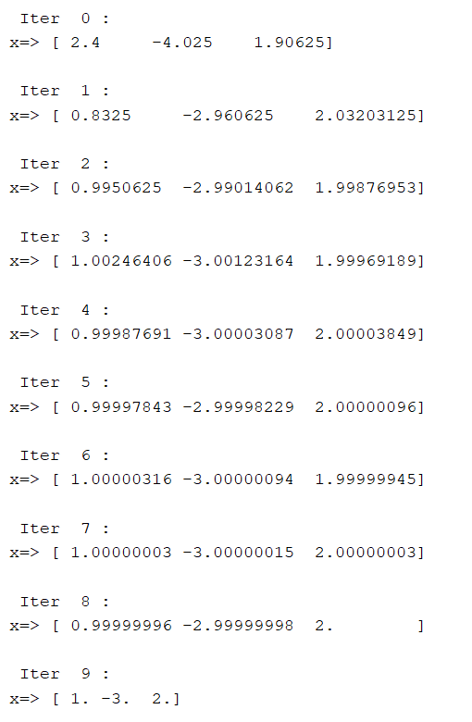

שיטות אינטרפולציה

בהינתן הקלט הבא:

# Example - some points in an array  
points_table = [(2, -3.6), (3, 1.25), (6, 4.1)]  
#points_table = [(0.2, 0.198669), (0.3, 0.295520), (0.4, 0.389418), (0.5, 0.479426)]  
  
# We choose 3 points from the table, so that the function f(x) will be in order 2  
xp = [points_table[0][0], points_table[1][0], points_table[2][0]]  
yp = [points_table[0][1], points_table[1][1], points_table[2][1]]  
  
# We calculate lagrange interpolation by sending 3 points and receiving function back  
f = interpol.lagrange(xp, yp)

x = 4  
print(**'f({0}) = {1}'**.format(x, f(x)))

p = neville(xp, yp, 4)  
print(p)

**lagrange interpolation**

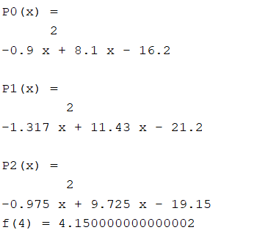

**Neville interpolation**

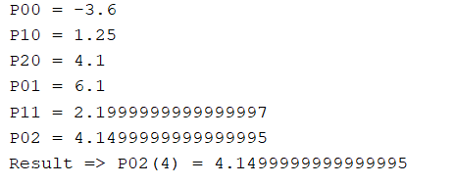

בהינתן הקלט:

# Example - some points in an array  
points_table = [(2, -3.6), (3, 1.25), (6, 4.1)]  
  
  
def InterpolateNatural(x_values, y_values, desired_x):  
 return Interpolate(x_values, y_values, 0, 0, desired_x)  
  
  
# x values, y values, the x we want to calculate its y  
print(InterpolateNatural([1, 2, 3, 4, 5], [1, 2, 1, 1.5, 1], 5))  
  
# the polynomial of each 2 dots  
index = 0  
for i in tuple(CubicSpline([1, 2, 3, 4, 5], [1, 2, 1, 1.5, 1], 0,0)):  
 print(**"s{0} = {1}"**.format(index, i))  
 index += 1

**Cubi-spline interpolation**

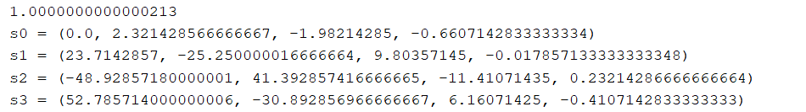

שיטות גזירה ואינטגרציה נומרית

בהינתן הקלט:



xp = [0, 0.5, 1, 3/2, 2, 5/2, 3]  
yp = [1, 32/33, 1/2, 32/275, 1/33, 32/3157, 1/244]  
print(**"Integral:"**, simpson(yp, xp))





**Trapezoidal integration**

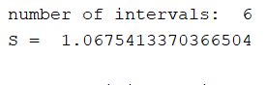

**Simpson integration**



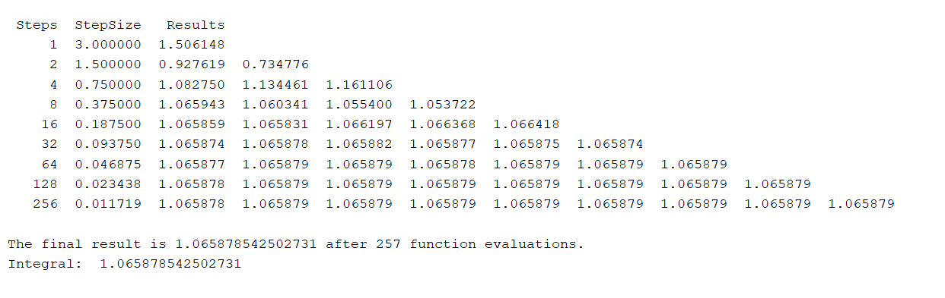**Romberg integration**

**Gaussian-quadrature integration**

